Logistic Regression(confusion matrix)

Input given:

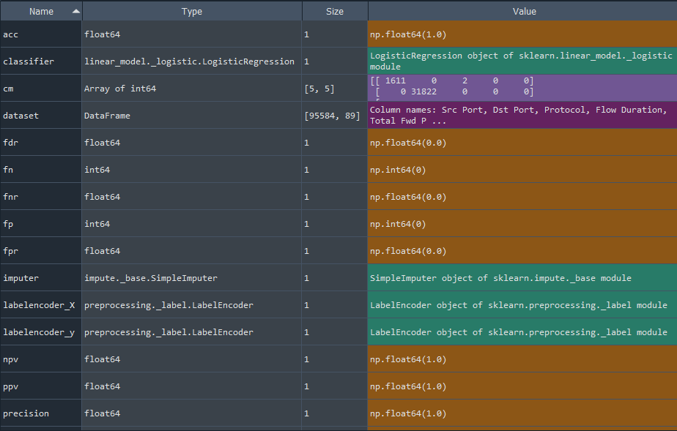

Output produced with LG.py

1)confusion matrix for y_test and y_pred

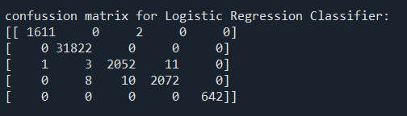

2)overall accuracy for classifier when test case is 80% train and 20% test

